**Overview:**

Create a virtual museum experience that allows users to explore exhibits, view detailed

information about artifacts, and engage with interactive content. The design should be

immersive, user-friendly, and visually captivating, ensuring that users have a rich and

educational experience.

**Case Study:**

How do you tell the story of an artist in a way that stimulates the senses virtually? How do you make it interactive and not just a visual/audio experience? Can those interactions be made accessible for people who have disabilities? Can we have interactive sketching exercises for people who are paralyzed or have amputated limbs? Can we showcasing art in a way that people who are blind can appreciate? How can you ensure that these experiences are the same for people without those disabilities?

**Our Goal:**

Our goal is to create an platform where user can visit an museum virtually at anytime any where

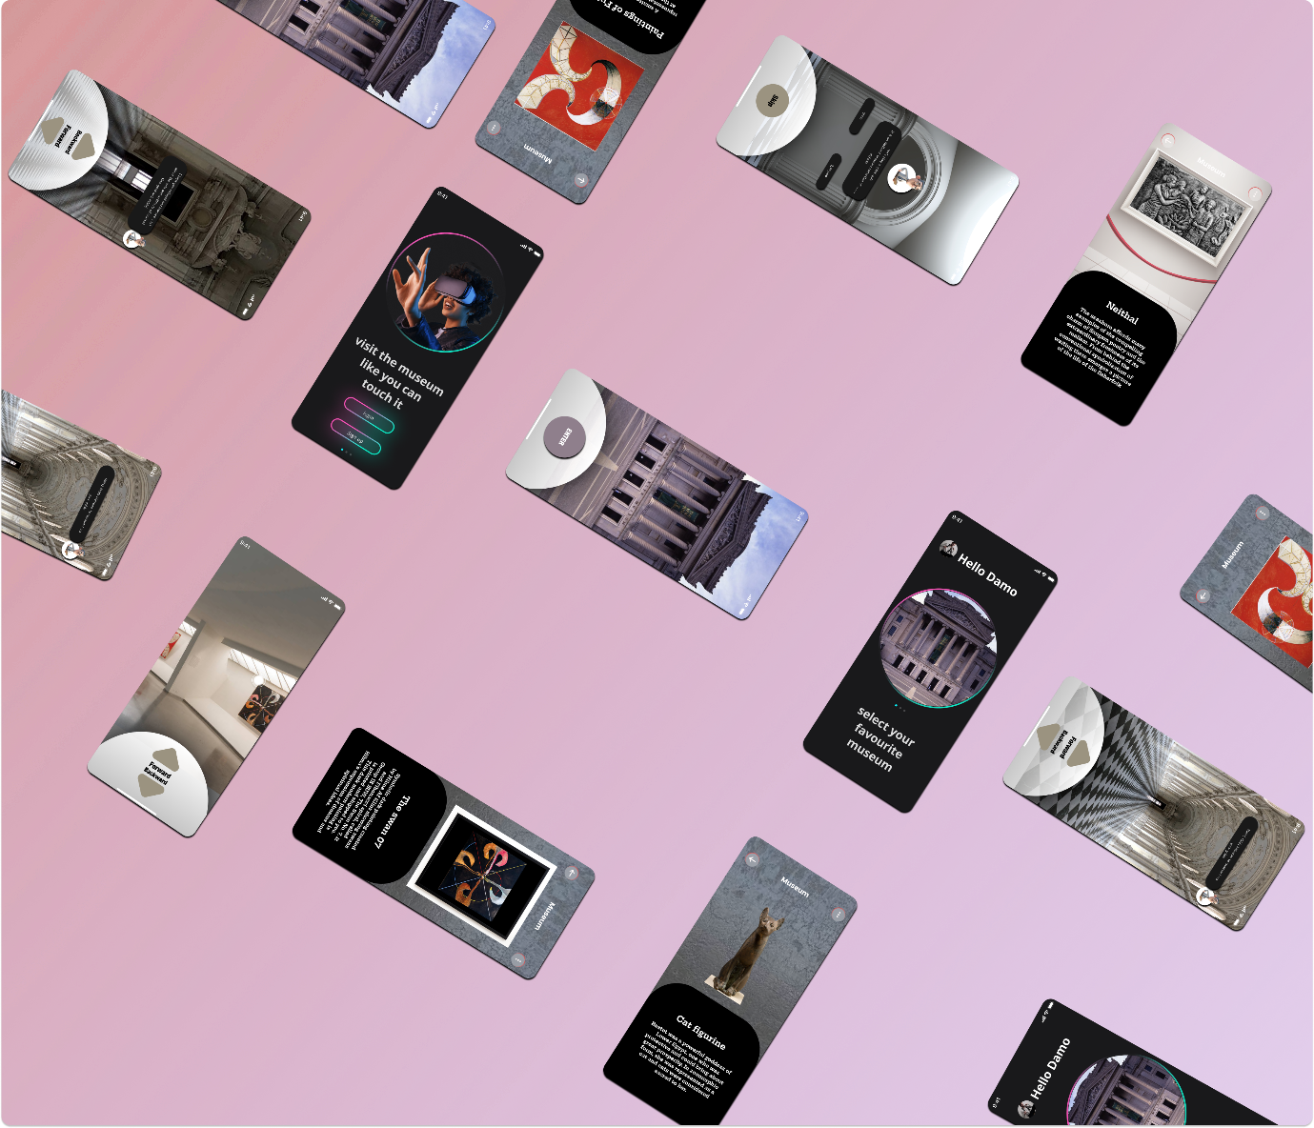

**Arts and Artifacts**

